# RFID Programing Station Software Guide

The goal of this application is to program RFID tags that are attached to reagent packs. The target audience of the application are the technicians that are tasked to assemble reagent packs. The technician would use a hand scanner to scan a barcode that holds information to which data set would be needed to store in the tags. The scanner would populate the information in the content section.

The application is fully automatic when valid information has been entered in content section. Scanning for RFID tags would start soon after the content data has been confirmed. The reagent data would be stored in the tag soon after the last tag has been found. The application would indicate the storing the data has been completed and is safe to move the reagent pack.

The application is also able to install new firmware onto the main controller.

### Recommended Work Flow

1. Enter information for the current set of reagent packs to be programmed. Ether enter the information manually, or using a hand scanner
2. Confirm all hardware and necessary information are valid and hardware is ready. Programming of RFID tags will commence automatically when these conditions are meant.
3. Start the mechanical feed that would place the reagent pack inside the RF field. The recommend speed for tag going across the RF field is 20mm/s (.78 in/sec).

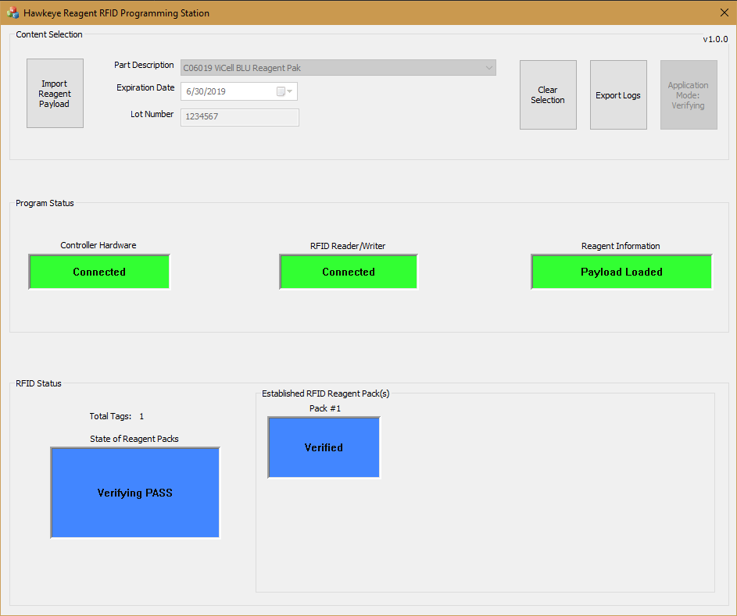

Figure : Full Application View

There are 3 main sections in the main screen of the application:

1. Content Selection
   * Select the data that will be stored in the RFID tag.
2. Program Status
   * The current state of the application.
3. RFID Status
   * The current state of programming or verification of RFID tag.

## Content Selection

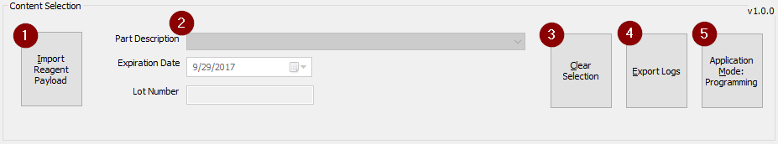

Figure : Application Section – Content Selection

The “Content Selection” section would show information about the reagent pack. (2). Scanning the barcode with the handheld scanner would load the payload data. The application would load known reagent packs from the lookup table file. (“ScountLookupTable_RevAA.txt”). This is the only method of entering information about the reagent packs. The technician would have to confirm the part description, the expiration date and the lot number before scanning the reagent packs.

The application has 4 operational buttons:

1. The “Import Reagent Payload” (1) button lets the technician to import additional reagent data payloads.
2. The “Clear Selection” (3) button lets the technician to clear the reagent information. The application will reset these values after 25 seconds of being idle.
3. The “Export Logs” (4) button lets the technician to transfer all the logs, that have been generated, into a separate folder location.
4. The “Application Mode” (5) button lets the technician to cycle between 2 applications modes:
   1. In “Programming Mode”, the application will program the first RFID tag that’s able to find in the scans.
   2. In “Verification Mode”, the application will compare the data that read back from the tag and the data from the selected reagent type.
   3. And the button will be disabled while scanning for tags.

## Program Status

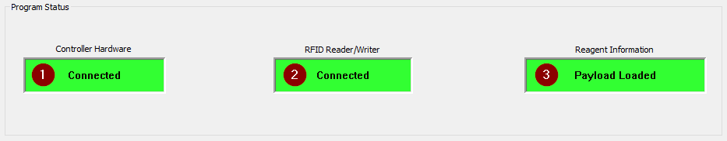

Figure : Application Section – Program Status

The Program Status section indicates the current state of the application. The application will start scanning for task when all have meant their required states. The states that are shown as a green indicator are the required for application start scanning and programming the RFID tags.

The following is the list of possible states for each indicator:

1. Controller Hardware
   * *Offline* – The application is trying to establish communication to the main controller board.
   * *Initialization Failed!* – The last attempt to communicate with the main controller board failed.
   * *Updating FW* – The application found that the current version of firmware on the main controller board is old or unsupported. It has started updating the firmware on the controller board.
   * *Firmware Update Completed* – Updating of the firmware on controller board has completed and resetting the board.
   * *Firmware Update Failed* – Updating the firmware failed and trying to reset the board.
   * *Connected* – The board is valid and communication has been established.
2. RFID Reader/Writer-
   * *Offline* – The RF reader has not been confirmed to be connected to the controller board.
   * *Error Occurred* – Commands to the RF reader has returned with errors.
   * *Connected* – Commutation to the RF reader has been confirmed.
3. Reagent Information
   * *Invalid!* – The application was unable to load or authenticate the reagents data files.
   * *Part Description Required* – The part description in Content Selection section was not entered. This combo box is required before the application would start scanning for RFID tags.
   * *Lot Number Required* – The Lot number has not been entered. This information must be entered before scanning for tags to occur.
   * *Payload Loaded* – The information that has been entered in Content Selection section is valid and data has been loaded to program RFID tags.
   * *Barcode Scan Invalid* – The barcode that has been scanned was missed read or damaged. Replace the tag if this occurs more than once on the same tag.
   * *GTIN Not Found in Known Entries* – The barcode was scanned successfully, however the application was unable to locate RFID data to match the barcode information.

## RFID Status

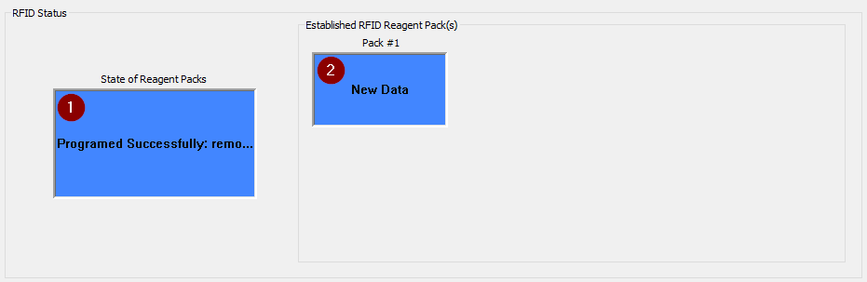

Figure : Application Section – RFID Status

The following list is the state that is possible for the following major sections:

1. *State of Reagents Packs* – This is the application state on scanning for tags and it also indicates the progress of programming the tags with selected data.
   * *Invalid –* The system is not ready to scan for tags
   * *RF Error –* The RF reader has reported a critical error and the application is trying to recover from it.
   * *Programming: do not move* –The application has started programming the RF tags.
   * *Programmed Successfully:* remove reagent pack(s) - The tags that have been located, have successfully programmed with new reagent data.
   * *Programed Failed:* Remove the reagent pack and try again – Programming reagent data in the reagent tags has failed. Remove tag from reader and replace it back to see if the application can try to program it.
   * *Clearing Payload Information* – The application was unable to detect any RFID tags and clearing the reagent information.
   * *Verifying* – Has started verifying data between RFID tag and selected reagent type.
   * *Verifying PASS* – The data match between RFID tag and selected reagent type.
   * *Verifying FAIL* – The data did not match between RFID tag and selected reagent type. A dialog message box will be displayed to confirm the failed verification. And the scanning for tag will stop and reagent selection will be cleared.
2. *Established RFID reagent Pack(s) [1…6]* – The application can detect up to 6 reagent pack tags. However, the current arraignment of the RF reader is only able to read 1 RF tag at a time.
   * *Offline* – No RFID tag was located.
   * *Invalid* – The RF reader could find the tag. However, was unable establish communication with it.
   * *Standing By* –The RF reader has established connected and ready to be programmed.
   * *Being Programmed* – The data is being transferred to the RF tag.
   * *New Data* – New data has been written to the RFID tag.

## Programming RFID, Write Error

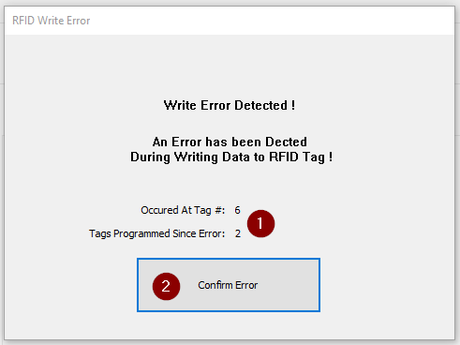

Figure : Dialog – RFID Write Error

This dialog is displayed when there has been an error during a programming of an RFID tag.

1. This section will display which tag the error occurred on. And how many successful tags have been programming since the error occurred.
   * This information would help to determine which tag caused the error.
2. Press the Confirm Error button to close the dialog. This will also stop the application from scanning for tags.

## Firmware Update

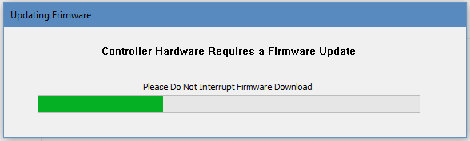

Figure : Dialog – Updating Firmware

The application can update the firmware on the main hardware controller board. This main hardware controller board is located inside the metal enclose box. The RFID reader/writer is connected to this board with 9 pin RS232 serial cable.

The application will start updating the firmware, when the `firmware_version` value in the configuration file does not match with controller’s reported version value. One would have to confirm the reported value from the new firmware, is the same has the recorded in the configuration file. There will be an infinite loop of updating the firmware if they do not match.



Source Code : ProgrammingStation.info

Be aware to not interrupt the updating of the controller board firmware. Disturbing the firmware update will result the controller board to be unresponsive

To create a new firmware binary file, one would need to use Hawkeye Win Encryption tool. This tool would take the new s-record text file and encoded into an encrypted binary file. This encryption tool will generate a new hash key for the new binary file. Copy this key value and place in the configuration file under ` bin_srecord_hashkey` variable.

## Installation & Configuration

* Application Installation
* Windows 10 Configuration
  + Create a New Administration Account
  + Desktop Configuration

### Application Installation

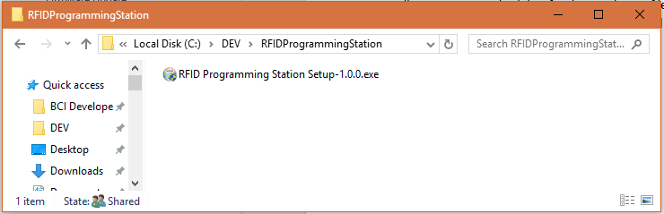

Figure : Installation File

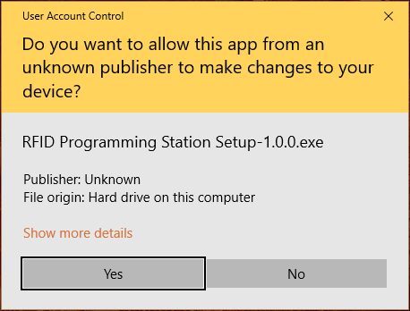

Figure : Windows 10 User Account Control dialog

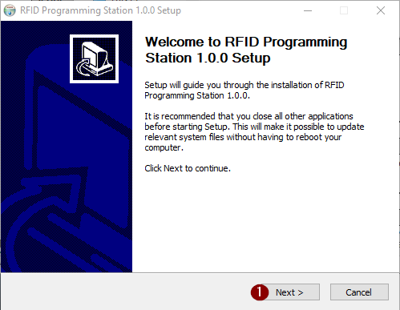

Figure : Initial Setup Dialog

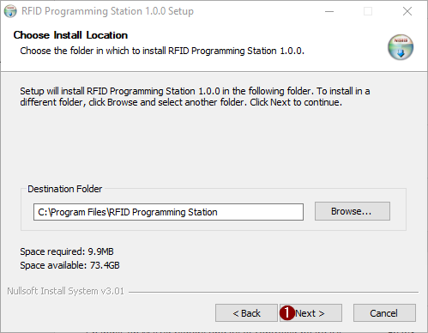

Figure : Install Location Dialog

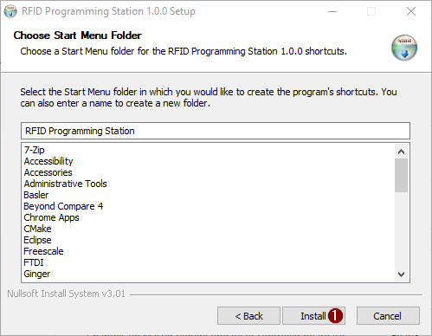

Figure : Start Menu Folder Dialog

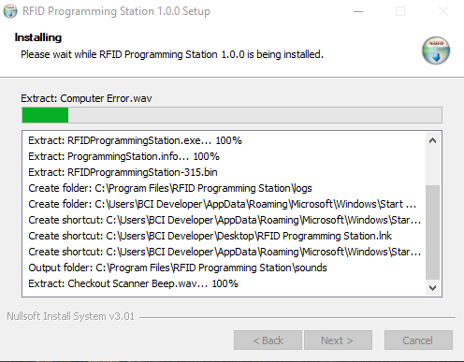

Figure : Installing Dialog

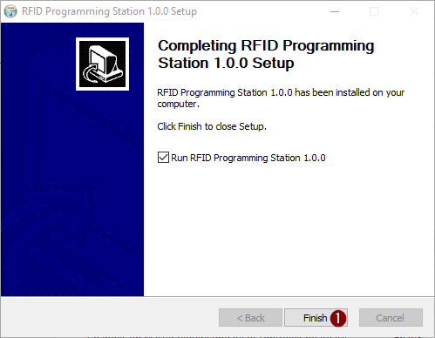

Figure : Completed Setup Dialog

### New Windows 10 Configuration

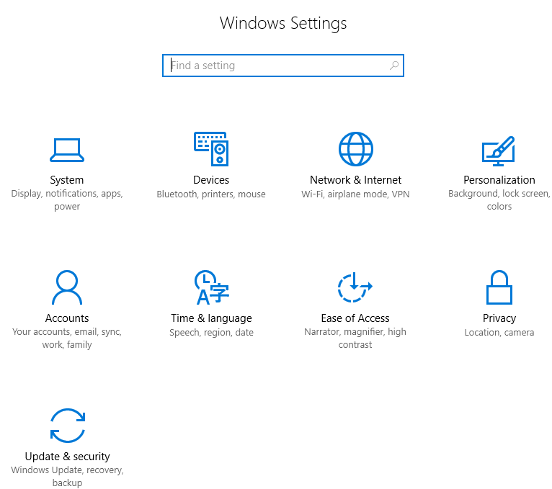

Figure : Windows 10 Settings

#### Create a New Administrator Account



Figure : Accounts Settings Icon

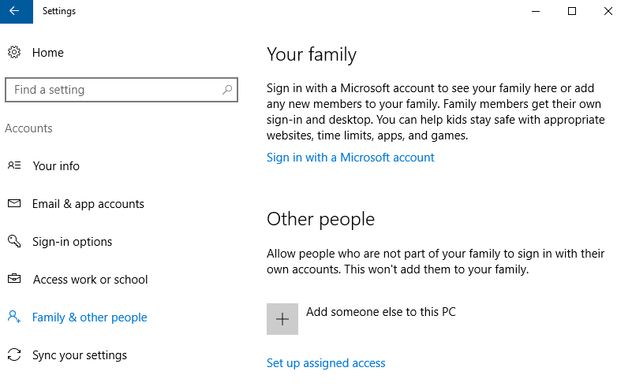

Figure : Account Settings

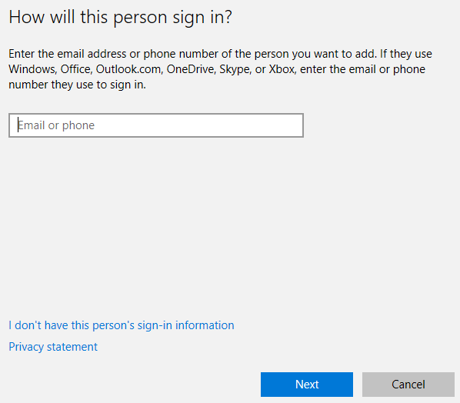

Figure : Sign In Dialog

* Click on “I don’t have this person’s sign-in information”

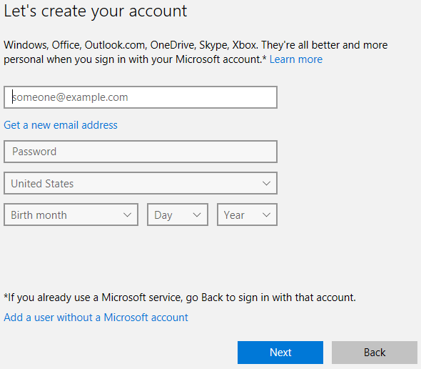

Figure : Create Account Dialog #1

* Leave password field blank.

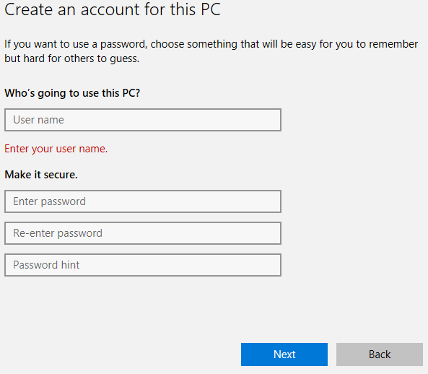

Figure : Create Account Dialog #2

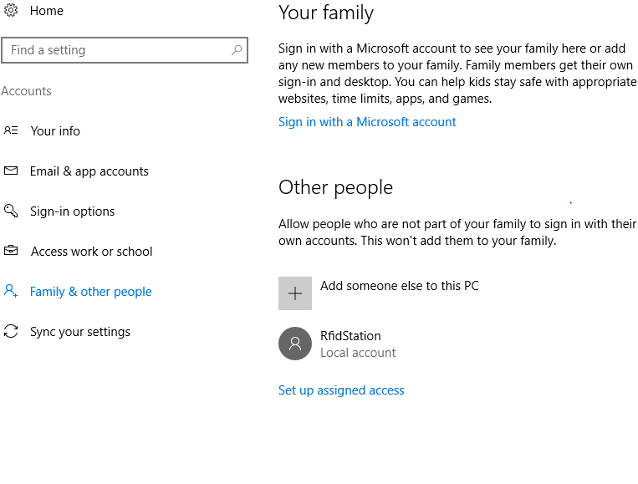

Figure : Account Settings with New Account added

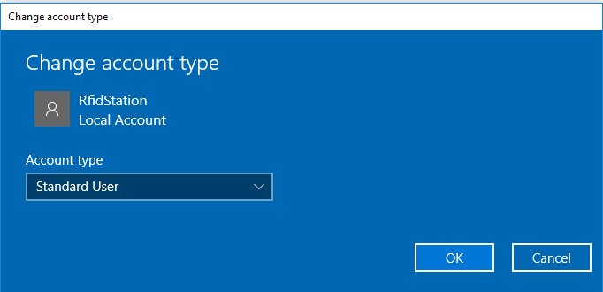

Figure :Change Account Type Dialog

#### Desktop Configuration



Figure : Personalization Settings Icon

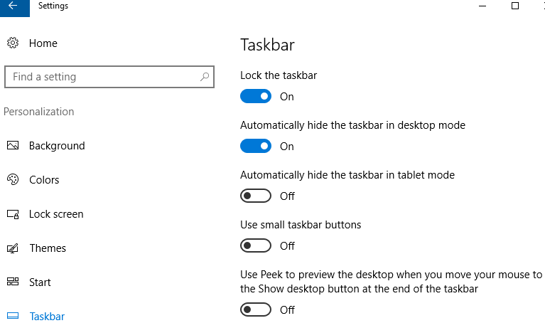

Figure : Taskbar Settings



Figure : System Settings Icon

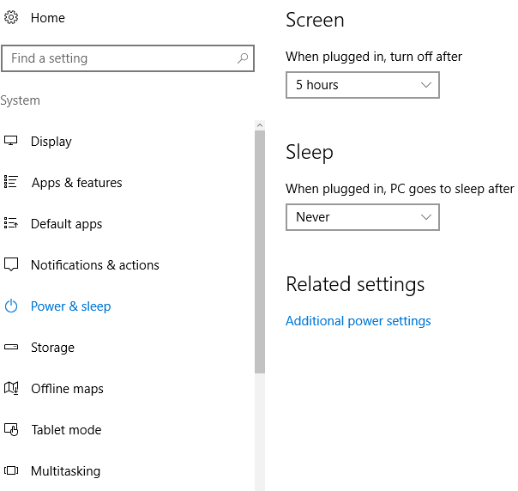

Figure : Power & Sleep Settings